My recommendation for working on the IER (Radar Imaging) Software would be to do so in a workspace separate from the other workspaces (such as RCAT/FlowTool/ACAT). I find it easier to deal with smaller workspaces, so this is how I have mine set up. Others choose to have one huge workspace.

I have included an **Eclipse Team Project Set (PSF file)** that may be imported into a new empty Eclipse workspace (mine is named **workspace_IER**). I keep all my workspaces in my local “user” directory (since my ID is **g137997**, my home is **C:\Users\g137997\** and the resultant workspace would be at **C:\Users\g137997\workspace_IER**).

Before importing the **PSF** there are a couple of things that need to be set up first (in the empty workspace):

1. **Create an empty workspace:** The name I use for the Radar Imaging workspace is **workspace_IER**. I keep all my workspaces in my local “user” directory thusly, since my ID is **g137997**, my home is **C:\Users\g137997\** and the resultant workspace would be in the directory **C:\Users\g137997\workspace_IER**.
2. **Default Repository Folder:** Configured via **Window > Preferences :: Team > Git**, this always seems to default to **u:\git** which is not really what we want. My recommendation would be to put the local repos in the workspace. Thus, if it were done as in step 1, the folder would be set to **C:\Users\g137997\workspace_IER** (Obviously your ID would replace mine in the namespace).  
   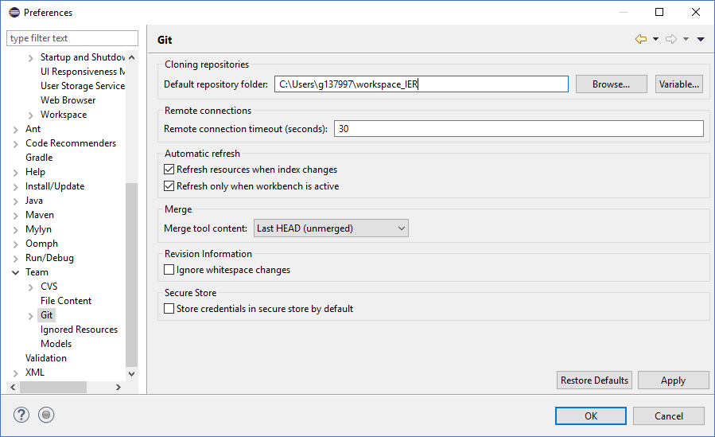
3. **SSH2 Configuration:** Configured via **Window > Preferences :: General > Network Connections > SSH2**:
   1. You will need to generate an RSA Key, and save it (via the **Save Private Key** button). You can use a pass phrase on the key if you wish but can also leave it blank. If you do use something other than blank, you will be prompted for it occasionally. I use a very short and simple password here.  
      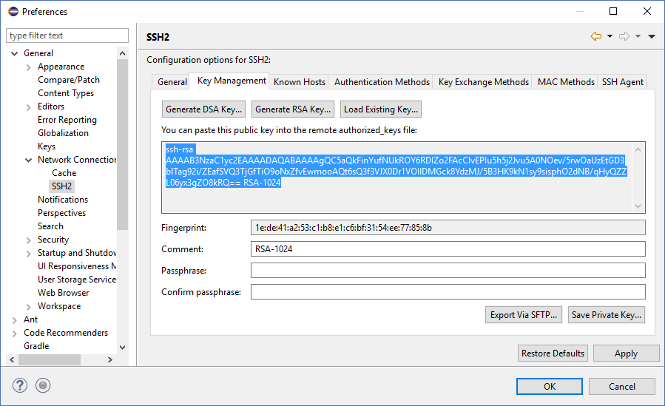
   2. Copy the public portion of the key in step **a** from the Eclipse dialog and paste it into the GitLab website under your IDs **SSH Keys** via the settings. Be sure to save it via the **Add Key** button.  
      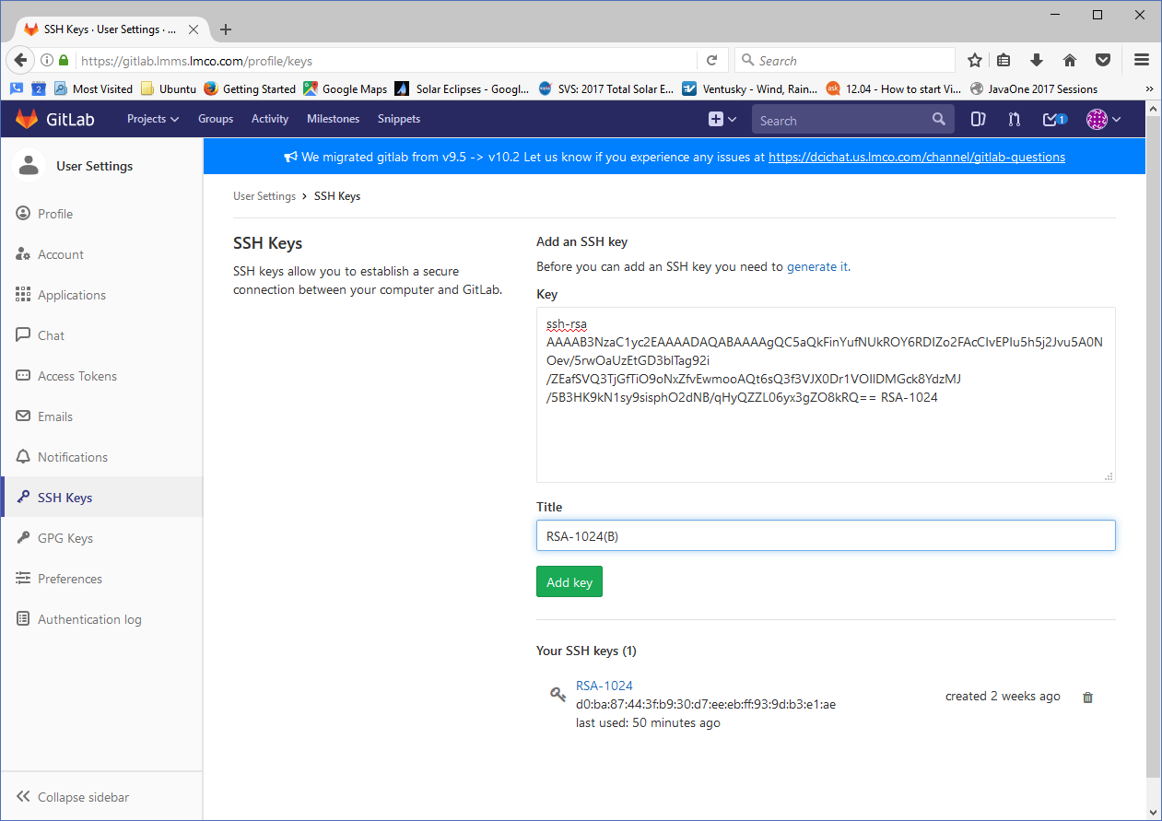
4. **Import PSF (Team Project Set):** Accomplished via **File > Import :: Team > Team Project Set**. This will set up the GIT repositories and add the projects to the workspace.
   1. Save the attached PSF file (**git_workspace_IER.psf**) somewhere on your system.
   2. Browse to the PSF file in the Import **Team Project Set** dialog (Note: you may want to check the **Run the import in the background** checkbox) and click the **Finish** button.  
      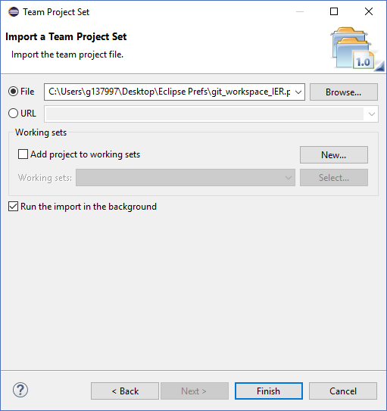
   3. The import will take a while.